**MANGALORE UNIVERSITY**

**Bachelor of Computer Applications (BCA) Degree Programme**

**Choice Based Credit System (2019-2020 Onwards)**

**III Semester – Practicals**

**BCAP 234**

**Visual Basic.NET Lab**

**Part - A**

1. Write a program to find the Sum of digit and check palindrome or not. Accept input through textbox and display the results in label. Also validate for invalid input such as empty input, nonnumeric and negative integer. (Marks distribution: Interface 4, Validations 3, logic Coding 5, Output 3)

|  |  |  |
| --- | --- | --- |
| **Object** | **Properties** | **Designation** |
| Label1 | Name | Label1 |
| Text | Enter a number |
| Label2 | Name | Label2 |
| Text | Sum |
| Label3 | Name | Label3 |
| Text | Reverse |
| Label4 | Name | Label4 |
| Text | Result |
| Label5 | Name | Label5 |
| Text | ---- |
| Label6 | Name | Label5 |
| Text | Answer |
| Textbox1 | Name | TextBox1 |
| Text | Enter a number |
| Textbox2 | Name | TextBox2 |
| Text | null |
| Textbox3 | Name | TextBox3 |
| Text | null |
| Button1 | Name | Button1 |
| Text | Display |

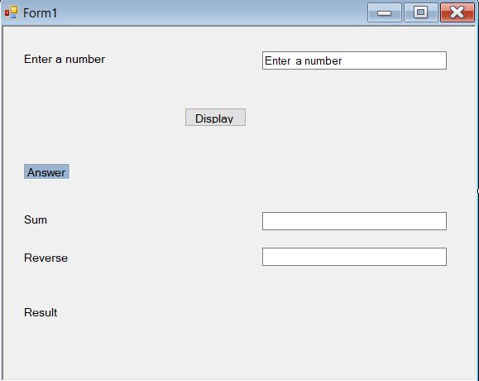

**Code:**

Public Class Form1

Private Sub Button1_Click(ByVal sender As System.Object, ByVal e As System.EventArgs) Handles Button1.Click

Dim num, rev, sum, res As Integer

If (TextBox1.Text = "") Then

MsgBox("Enter any value to the text boc")

ElseIf Not IsNumeric(TextBox1.Text) Then

MsgBox("Enter numeric value")

ElseIf TextBox1.Text <= 0 Then

MsgBox("Enter positive number")

End If

num = Val(TextBox1.Text)

While (num > 0)

res = num Mod 10

rev = rev * 10 + res

sum = sum + res

num = num / 10

End While

TextBox2.Text = sum

TextBox3.Text = rev

If Val(TextBox1.Text) = Val(TextBox3.Text) Then

Label5.Text = "palindrome"

Else

Label5.Text = "not palindrome"

End If

End Sub

End Class

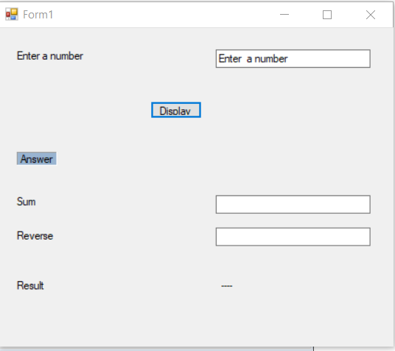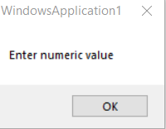

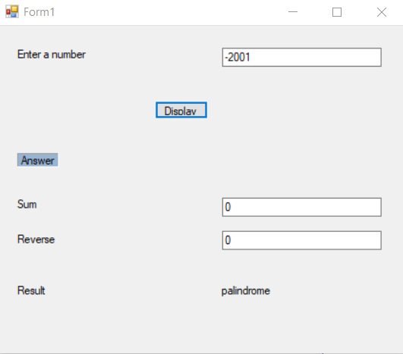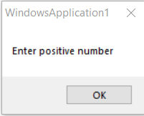

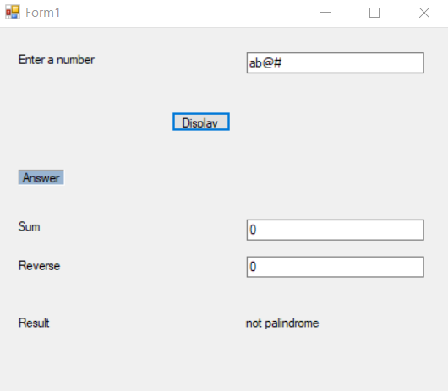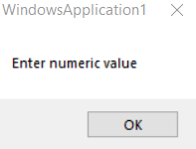

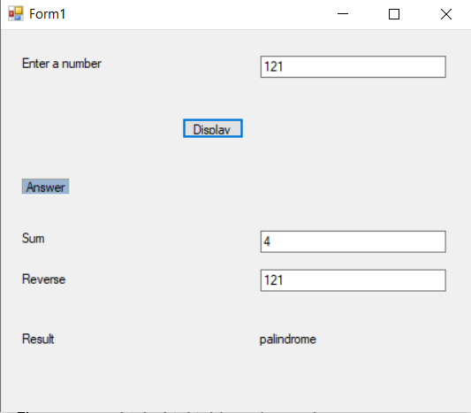

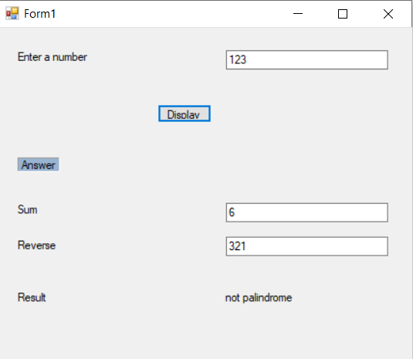

2. Create 3 forms Yourself.vb, Yourplace.vb and College.vb where each includes a rich textbox containing the respective information. Create an MDI form with menu options to open all these forms as child forms, closing them and rearrange the child forms as follows. Child Forms Window Open Cascade Close Tile Horizontal Tile vertical Arrange icons. (Marks distribution: Interface 3, creating 3 child forms 3, Coding 6, Output 3)

|  |  |  |
| --- | --- | --- |
| **object** | **properties** | **Designation** |
| Form1 | Name | Form1 |
| Text | Form1 |
| is mdi container | True |
| Form2 | Name | Yourself |
| Text | Yourself |
| Form3 | Name | Yourplace |
| Text | Yourplace |
| Form4 | Name | Collage |
| Text | Collage |
| MenuStrip1 | Name | MenuStrip1 |
| Text | MenuStrip1 |
| ToolStripMenuItem1 | Name | ChildformToolStripMenuItem |
| Text | Child forms |
| ToolStripMenuItem2 | Name | WindosToolStripMenuItem |
| Text | Window |
| ToolStripMenuItem3 | Name | OpenToolStripMenuItem |
| Text | open |
| ToolStripMenuItem4 | Name | CloseToolStripMenuItem |
| Text | close |
| ToolStripMenuItem5 | Name | CascadeToolStripMenuItem |
| Text | Cascade |
| ToolStripMenuItem6 | Name | TileHorizontalToolStripMenuItem |
| Text | Tile Horizontal |
| ToolStripMenuItem7 | Name | TileVerticleToolStripMenuItem |
| Text | Tile Verticle |
| ToolStripMenuItem8 | Name | ArrangeLconToolStripMenuItem |
| Text | Arrange Icons |
| RichTextBox1 | Name | RichTextBox1 |
| Text | GFGC  Thenkanidiyur  Udupi |
| RichTextBox1 | Name | RichTextBox1 |
| Text | Nittur  Nagodi (village),  Hosanagara tq,  Shivamogga dist.  Karnataka - 477452 |
| RichTextBox1 | Name | RichTextBox1 |
| Text | Vignesh n u |

Code:

Public Class Form1

Private Sub OpenToolStripMenuItem_Click(ByVal sender As System.Object, ByVal e As System.EventArgs) Handles OpenToolStripMenuItem.Click

Yourself.MdiParent = Me

Yourplace.MdiParent = Me

College.MdiParent = Me

Yourself.Show()

Yourplace.Show()

College.Show()

End Sub

Private Sub CloseToolStripMenuItem_Click(ByVal sender As System.Object, ByVal e As System.EventArgs) Handles CloseToolStripMenuItem.Click

Yourplace.Close()

Yourself.Close()

College.Close()

End Sub

Private Sub CascadeToolStripMenuItem_Click(ByVal sender As System.Object, ByVal e As System.EventArgs) Handles CascadeToolStripMenuItem.Click

Me.LayoutMdi(MdiLayout.Cascade)

End Sub

Private Sub TileHoeizantalToolStripMenuItem_Click(ByVal sender As System.Object, ByVal e As System.EventArgs) Handles TileHoeizantalToolStripMenuItem.Click

Me.LayoutMdi(MdiLayout.TileHorizontal)

End Sub

Private Sub TileVerticalToolStripMenuItem_Click(ByVal sender As System.Object, ByVal e As System.EventArgs) Handles TileVerticalToolStripMenuItem.Click

Me.LayoutMdi(MdiLayout.TileVertical)

End Sub

Private Sub ArrangeIconsToolStripMenuItem_Click(ByVal sender As System.Object, ByVal e As System.EventArgs) Handles ArrangeIconsToolStripMenuItem.Click

Me.LayoutMdi(MdiLayout.ArrangeIcons)

End Sub

End Class

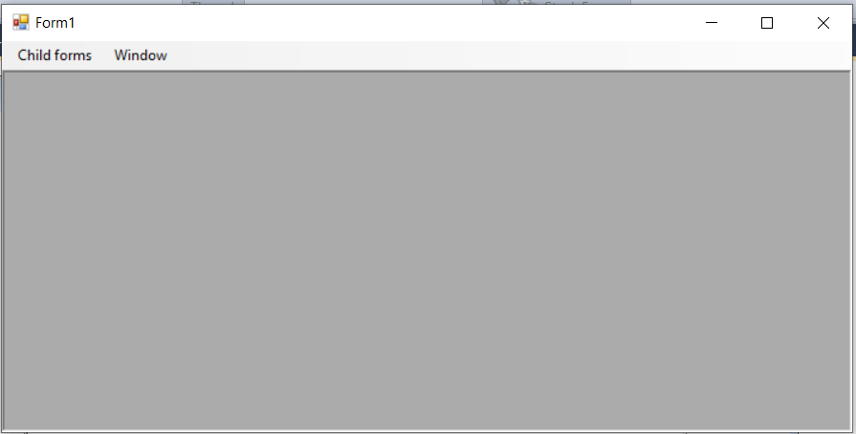

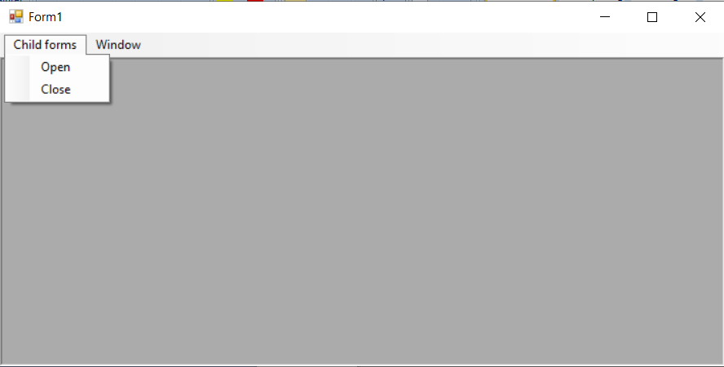

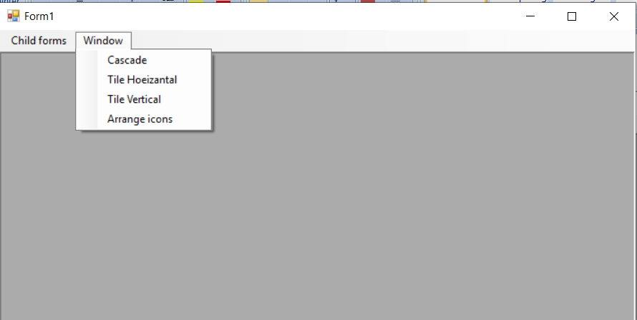

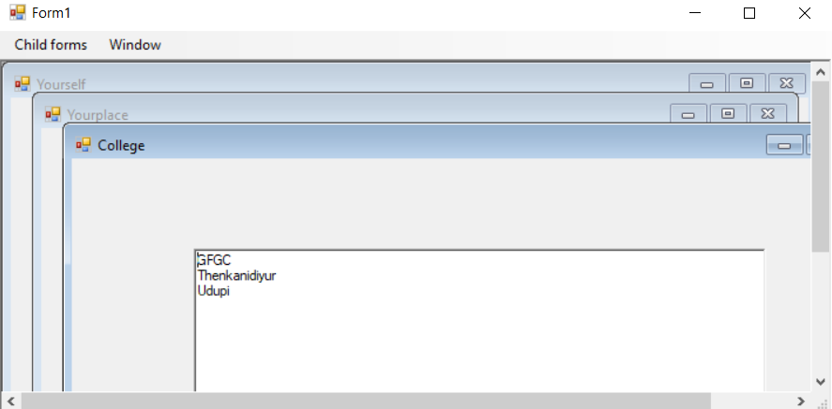

Cascade:

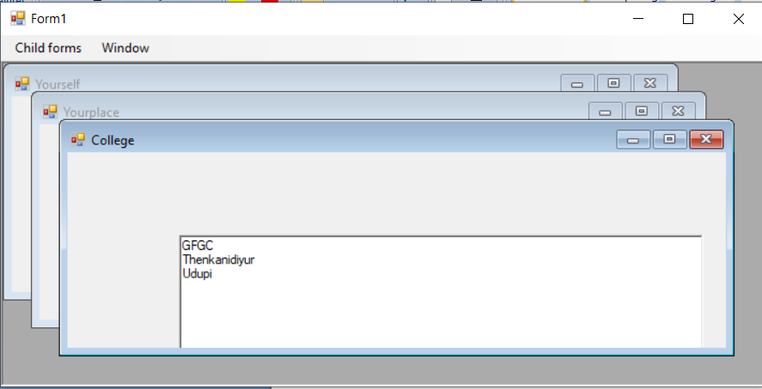

Tile horizontal:

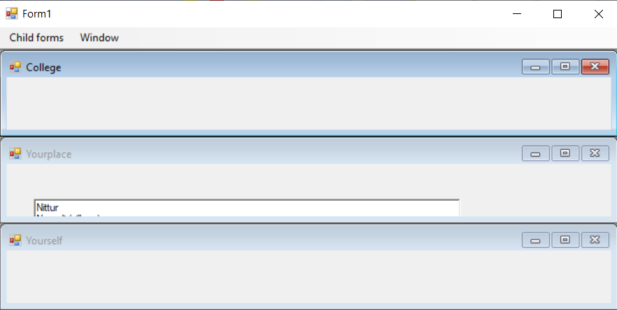

Tile vertical:

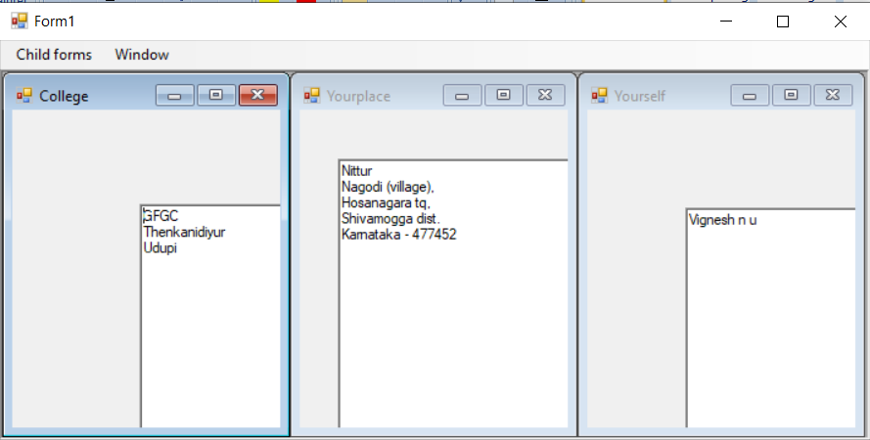

Arrange icons:

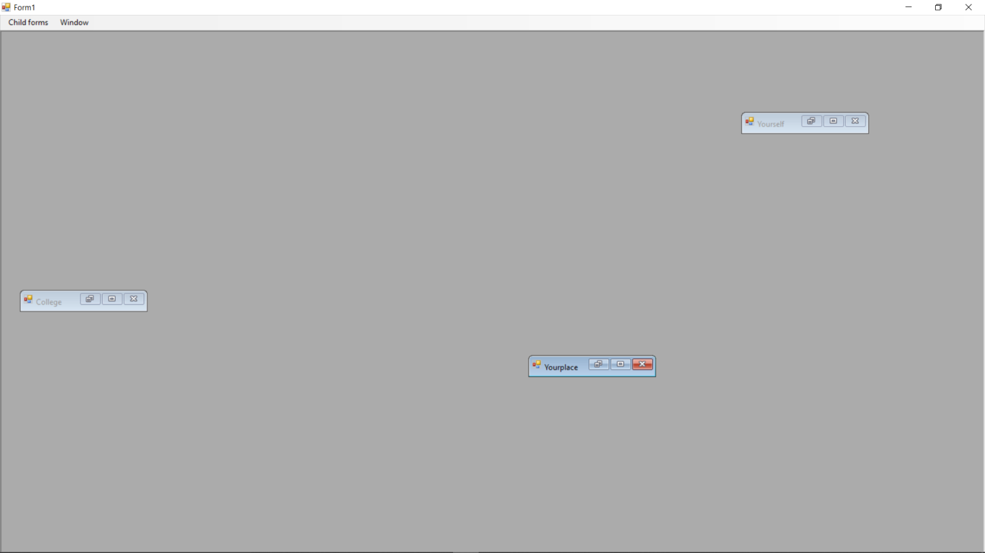



3. Design a form to accept number of books to be ordered to a shop in a textbox. By clicking a button ‘Continue’, if accepted number is > 0, then place required number of textboxes on the form to accept the details Title, Author and Copies, during run time to accept details of specified number of books. By clicking a button ‘Next’ on this form, enabling progression bar, send the details to another form to show the summary of the books ordered. (Marks distribution: Interfaces 4, Coding 8, Output 3)

|  |  |  |
| --- | --- | --- |
| **Objects** | **Properties** | **Designation** |
| Label1 | Name | Label1 |
| Text | Enter the number of books to be Ordered |
| Label2 | Name | Label2 |
| Text | Enter title, author and copies below |
| Label3 | Name | Label3 |
| Text | Title |
| Label4 | Name | Label4 |
| Text | Author |
| Label5 | Name | Label5 |
| Text | No of copies |
| Label6 | Name | Label6 |
| Text | Label6 |
| Button1 | Name | Button1 |
| Text | Btncontinue |
| Button2 | Name | Button2 |
| Text | Btnquit |
| Button3 | Name | Button3 |
| Text | Btn_next |
| GroupBox1 | Name | GroupBox1 |
| Text | Book details |
| ProgressBar1 | Name | ProgressBar1 |
| Textbox1 | Name | TextBox1 |
| Text | Null |
| Form2 | Name | ordersummary |
| Text | ordersummary |
| Textbox1 | Name | Txtsummary |
| Text | Null |

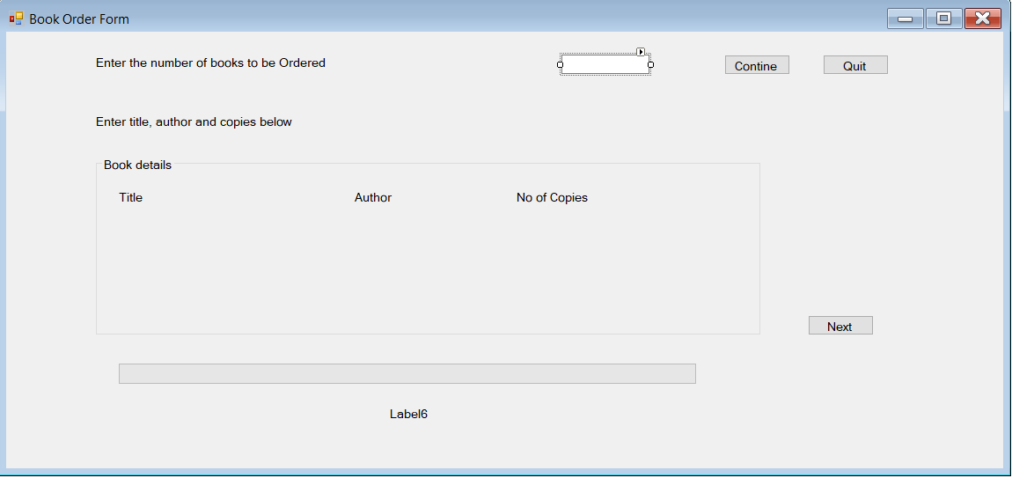

Code:

Public Class Form1

Dim i, j, n As Integer

Dim info As String

Private Sub Btncontinue_Click(ByVal sender As System.Object, ByVal e As System.EventArgs) Handles Btncontinue.Click

n = Val(TextBox1.Text)

If (n > 0) Then

Dim y = 2

Dim x = 2

Dim no = 0

For i = 1 To n

For j = 1 To 3

no = no + 1

Dim Textbox As New TextBox

Textbox.Name = "Textbox" & no

MsgBox(Textbox.Name)

Textbox.Size = New Size(150, 20)

Textbox.Location = New Point(x, y + 50)

x = x + 160

GroupBox1.Controls.Add(Textbox)

Next

y = y + 40

x = 2

Next

Else

MsgBox("Enter number of books to be ordered")

End If

End Sub

Private Sub Btn_next_Click(ByVal sender As System.Object, ByVal e As System.EventArgs) Handles Btn_next.Click

Timer1.Enabled = True

info = ""

For i = 1 To n * 3

info = info & " " & GroupBox1.Controls.Item("TextBox" & i.ToString).Text & Space(5)

If i Mod 3 = 0 Then

info = info & vbCrLf

End If

Next

End Sub

Private Sub Timer1_Tick(ByVal sender As System.Object, ByVal e As System.EventArgs) Handles Timer1.Tick

ProgressBar1.Value = ProgressBar1.Value + 5

Label3.Text = "Please wait ! order summary is loading..." & ProgressBar1.Value & "%"

If ProgressBar1.Value = ProgressBar1.Maximum.ToString Then

Timer1.Enabled = False

ordersummary.Show()

ordersummary.Txtsummary.Text = "You ordered " & n & " books" & vbCrLf & "Title Author No of copies " & vbCrLf & info

End If

End Sub

Private Sub Btnquit_Click(ByVal sender As System.Object, ByVal e As System.EventArgs) Handles Btnquit.Click

End

End Sub

End Class

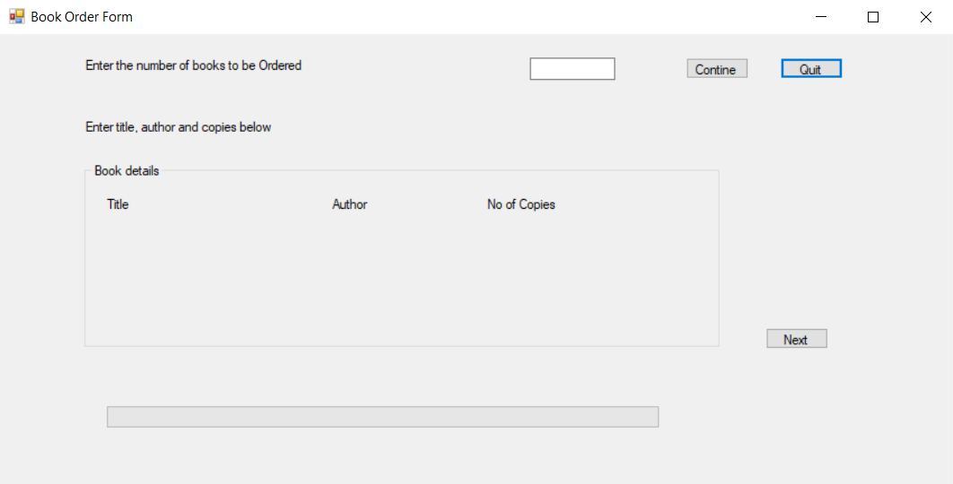

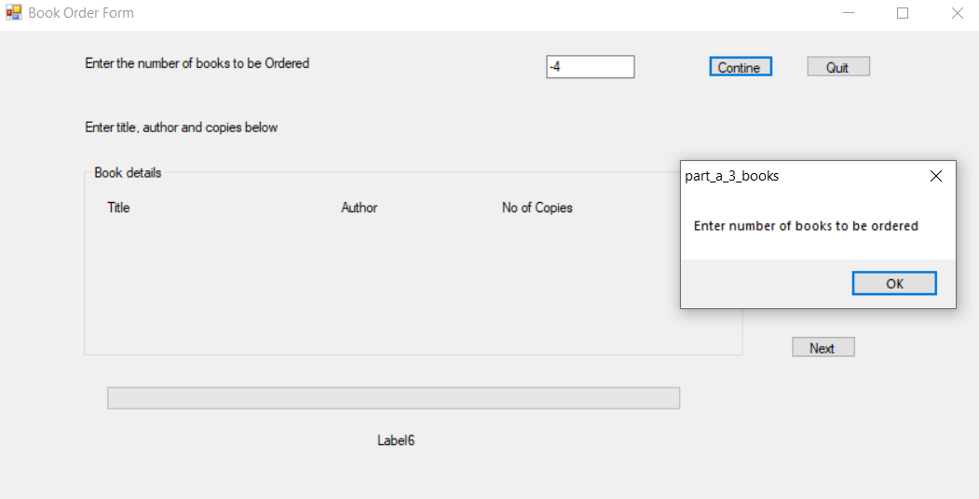

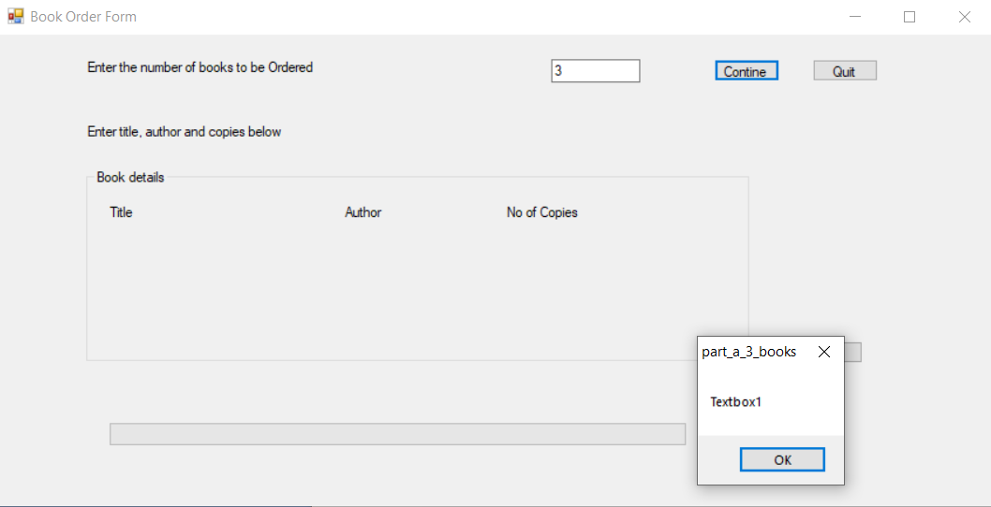

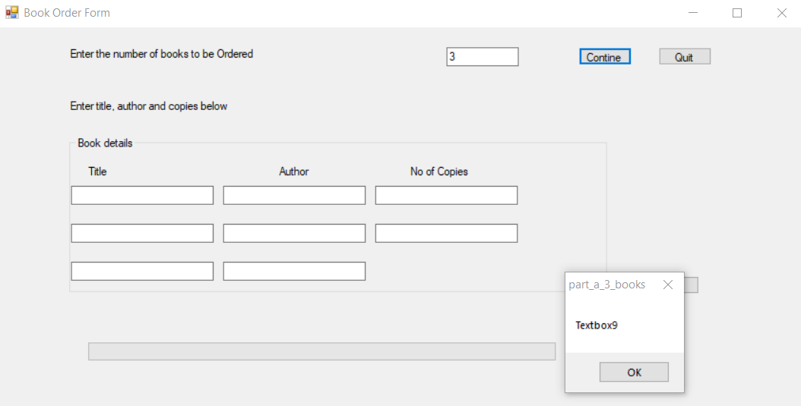

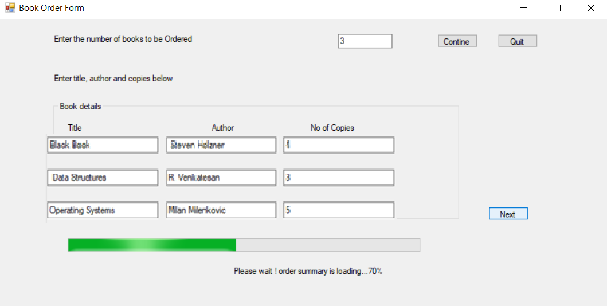

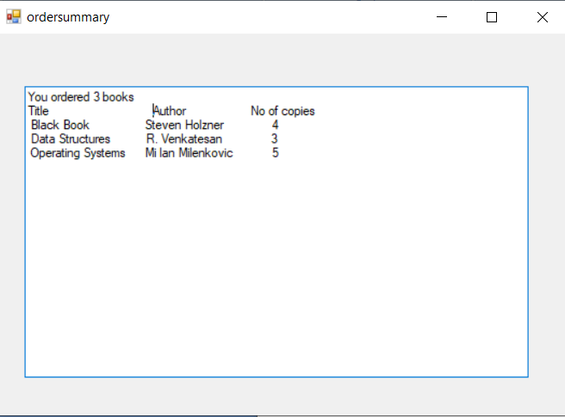

4. Crete a tree structure using TreeView control with at least 3 nodes with 2 sublevel nodes under each node. When any node is clicked display the text in a label and when the mouse pointer moves to this label change the font color by applying the color selected in default color dialog box. [Use ColorDialog control and MouseMove() event] (Marks distribution: Interfaces 4, Coding 8, Output 3)

|  |  |  |
| --- | --- | --- |
| **Object** | **Property** | **Description** |
| Label1 | Name | Label1 |
| Text | To show the tree view structure |
| Label3 | Name | Label3 |
| Text | Label3 |
| TreeView1 | Name | TreeView1 |
| ColorDialog1 | Name | ColorDialog1 |

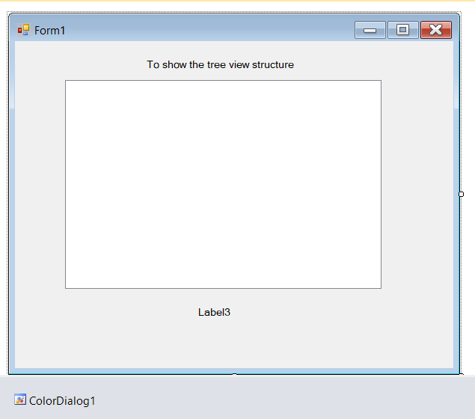

Code:

Public Class Form1

Private Sub Form1_Load(ByVal sender As System.Object, ByVal e As System.EventArgs) Handles MyBase.Load

With TreeView1

.BeginUpdate()

.Nodes.Add("Fruit")

.Nodes(0).Nodes.Add("Apple")

.Nodes(0).Nodes(0).Nodes.Add("Red apple")

.Nodes(0).Nodes(0).Nodes.Add("Green apple")

.Nodes(0).Nodes.Add("grapes")

.Nodes(0).Nodes.Add("Pineapple")

.Nodes(0).Nodes.Add("Watermeion")

.Nodes.Add("Vegitables")

.Nodes(1).Nodes.Add("Tomato")

.Nodes(1).Nodes.Add("Brinjai")

.Nodes(1).Nodes.Add("Cucumber")

.Nodes(1).Nodes.Add("Cabbage")

.Nodes.Add("grossesries")

.Nodes(2).Nodes.Add("Rice")

.Nodes(2).Nodes.Add("Sugar")

.Nodes(2).Nodes.Add("Salt")

.Nodes(2).Nodes.Add("Dal")

.EndUpdate()

End With

End Sub

Private Sub TreeView1_AfterSelect(ByVal sender As System.Object, ByVal e As System.Windows.Forms.TreeViewEventArgs) Handles TreeView1.AfterSelect

Me.Label3.Text = TreeView1.SelectedNode.Text

Me.Label3.Text = "You clicked : " & e.Node.Text

End Sub

Private Sub Label3_MouseMove(ByVal sender As System.Object, ByVal e As System.Windows.Forms.MouseEventArgs) Handles Label3.MouseMove

If ColorDialog1.ShowDialog = Windows.Forms.DialogResult.OK Then

Label3.ForeColor = ColorDialog1.Color

End If

End Sub

End Class

